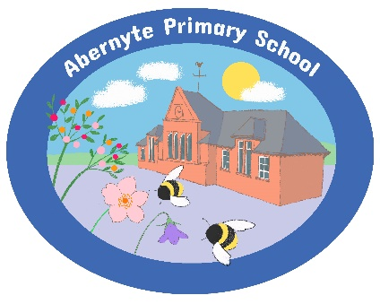GIRFEC outlined.eps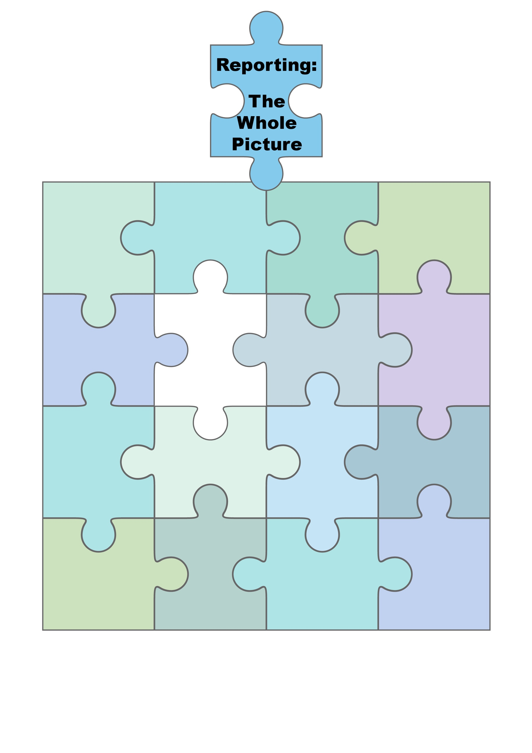

Open doors (termly)

HT curriculum sharing for P1 (2 transition dates in June prior to starting school)

School updates- through HT update at Parent Council- termly newsletters, email and phone calls.

Learner Led Conference/

PATPAL- Term 3

How to help your child at home.

Learning conversations=

Teacher

Pupil

Parent

Carer

Feedback from regulatory bodies.

Twitter @... [Abernyte Primary (@AbernyteP) / Twitter](https://twitter.com/AbernyteP)

Community events and

Performances.

Homework sharing sessions.

End of year written report Term 4

Learning  
walls  
and  
displays

Parent contact- phone call, teams or face to face Term 1, 3 and 4.

Website- [Abernyte Primary School, Inchture, Perthshire](https://www.abernyteprimary.co.uk/)

Share the learning overviews- how parents can help at home (termly)

The ‘Reporting Jigsaw’ above is an overview of all the opportunities that Abernyte Primary school are providing to parents and carers as a way of communicating and reporting children’s progress and learning this session 2023-24.

Next steps for learning 