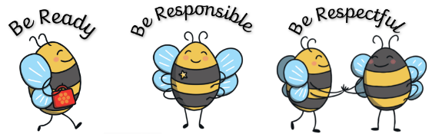
Our Values and Rules
Be Ready, Be Responsible, Be Respectful

Be Responsible | - Organised  - Ask for help when you need it  - Stay focused  - Try your best  - Follow instructions promptly  - Be a positive representation of the school
Be Respectful | - Enter the classroom and school quietly  - Listen well  - One voice at a time  - Treat others like you would like to be treated  - Use an appropriate voice level  - Respect property and equipment  - Be kind  - Be proud of your school
Be Ready | Resilient-  - I have a growth mindset and I never give up.  - I am self-motivated and have a positive, ‘can do’ attitude.  Evaluates-  - Through self-assessment I can talk about where I am in my learning and recognise my strengths and next steps.  - I can receive for myself and give feedback to others to help us achieve greater success.  - I ask myself if this is my best and see mistakes as a learning opportunity to improve.  Ambitious-  - I use both open and closed questions to gain knowledge and further ideas.  - I enjoy a challenge and can take charge of my learning.  Determined-  - I am not afraid to ask for help.  - I can listen, concentrate and organise myself.  - I have confidence when learning is challenging and can use various strategies to help me.  Younique-  - I am an independent, motivated learner making sensible choices.  - I help other to learn.  - I ensure that I am the best I can be at all times.

