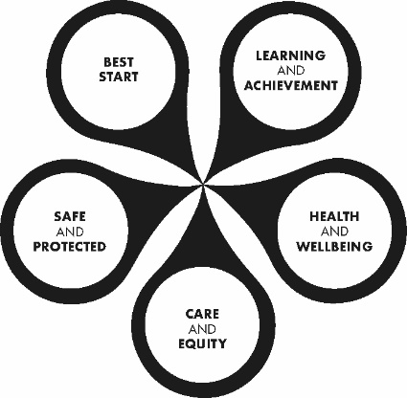 | Education & Children’s Services  Improving Lives Together  Ambition I Compassion I Integrity  Abernyte Primary  Cost of the School Day

Key links which may offer some support:

School Meals
- All pupils from Primary 1 to Primary 5 can access a school meal at no cost each day without the need for parents/carer to apply. This will be expanded to include Primary 6s and Primary 7s by 2024. Menus are available via Primary school meals - Perth & Kinross Council (pkc.gov.uk). Pupils wishing to have a meal can choose their choice each morning.

- Families with pupils in P1-P5 can also apply for a clothing grant of £126 per year if you are in receipt of certain benefits. If your child is currently in P6 and P7 you can apply online for free school meals and a clothing grant if you are in receipt of certain benefits.

- All the information for clothing grants and free school meals along with an online application form can be accessed here - Free school meals and school clothing grants - primary and secondary - Perth & Kinross Council (pkc.gov.uk)

Available Benefits
- This page lists all the current benefits that are available to families. Some of them are available to all and some are based on levels of benefits received - Benefits for parents, children and young people - Perth & Kinross Council (pkc.gov.uk)

Local Food Larders
  - This page lists details of local food share larders that aim to reduce food waste and support families - Local larders - Food support for people in Perth and Kinross - Perth & Kinross Council (pkc.gov.uk)

Cost of the school day
  - We are continuing to focus on how we can reduce the cost of the school day. This includes things like cost of trips and uniform costs.

  - We would also like to offer a free daily ‘tuck’. Initially, this will be an offer of a piece of fruit at break at morning interval but if there is interest we would be happy to offer toast each morning after the October holidays for all pupils in P1-P7.

If any families need support in accessing these services and supports or help in completing the applications, then please email the Headteacher at jenniferclark@pkc.gov.uk.

