Positive Behaviour and Learner Qualities

At Abernyte Primary we believe that children learn and develop best when they are part of a culture of mutual respect with clear expectations of how they and others should behave. Through interactions and guidance from trusted and caring adults, who provide a good role model and value their individual personalities, pupils can develop empathy and understanding of how their interactions affect both others and the learning environment.

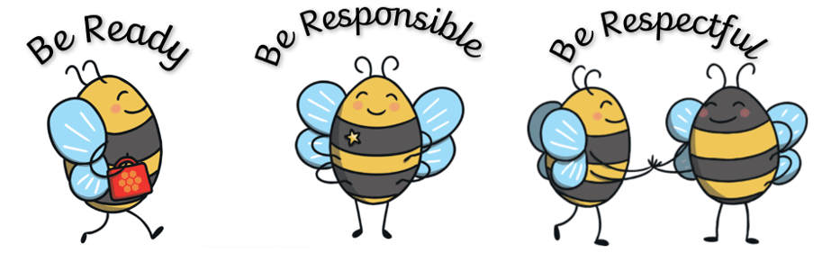
Our school code of conduct was agreed with pupils and based on the UN Right of the Child. This session we revisited our school rules, and are happy that they are short and memorable for all pupils:

As a school we have taken on visible learning practices because there is strong evidence that it makes a positive impact on learner outcomes. Our children are empowered to direct their own learning beyond their time at Abernyte because they are active participants of their learning, whilst here. At Abernyte we have developed a learning partnership which involves:

- Teachers and learners identifying learning intentions and success criteria for achieving these
- Rich conversations between teachers and learners that continually build on learning, empowering children to be proactive learners
- Effective, timely feedback from teachers and peers to enable children to progress in their learning
- The active involvement of children in analysing their assessment data, identifying next steps and setting challenging goals
- Teachers responding to identified learning needs and strengths by modifying their teaching approach(es)
We believe our children leave us at the end of Primary 7 with a skillset which will enable them to be successful lifelong learners.
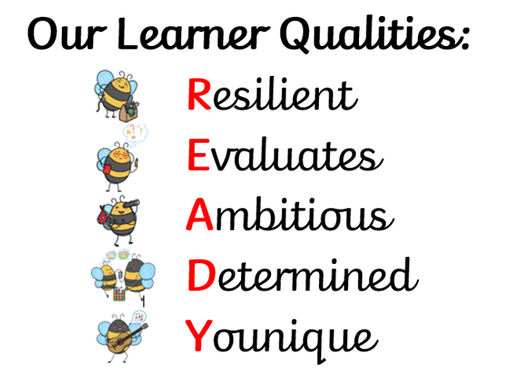
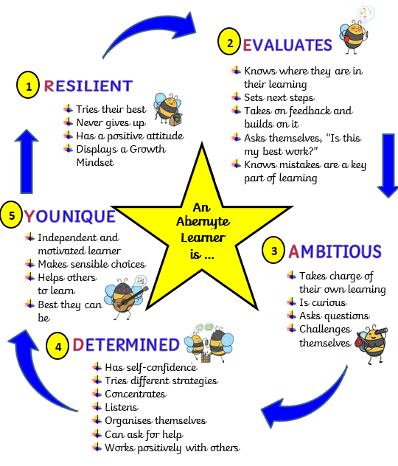

These diagrams can be found everywhere in our school. They are one of the key ways that as a school, we ensure a consistency in both the language we use with the pupils as well as the high standards and expectations we work with them to achieve. They are also a fantastic way of helping parents and carers of our pupils work in partnership with us to help all of our pupils to achieve these high standards and expectations.

Our Relationships Policy principles have been agreed through discussion with staff, pupils and parents/carers. In Abernyte we are proactive in promoting positive relationships and behaviour in the classroom, playground and the wider school community. We view all behaviour as a communication establishing open, positive, supporting relationships across the community, where children and young people will feel that they're listened to, and where they feel secure in their ability to discuss sensitive aspects of their lives. We use restorative approaches to support communication. Staff do not raise their voices but re-direct children to alternative activities until they are calm enough to be part of a restorative conversation. At Abernyte we promote a climate in which children and young people feel safe and secure. Supporting children to develop a growth mindset permeates all aspects of learning and teaching at Abernyte. At Abernyte we ensure that a consistent, high standard of behaviour is expected from all pupils and that a system of positive and fair reinforcement is in place. We ensure that the environment offers a safe base so in developing relationships and wellbeing we must ensure an environment that is conducive to learning and takes into account individual needs.

Bullying takes many forms. It can be physical, verbal, emotional or cyber, but it is always a repeated behaviour that makes others feel uncomfortable or threatened. We acknowledge that any form of bullying is unacceptable and will be dealt with immediately as per the Perth and Kinross Council anti-bullying guidelines, sourced at

http://www.pkc.gov.uk/article/17426/Bullying-and-harassment

Using our school code of conduct we promote various positive behaviour strategies including:
- Restorative conversations
- Use of Circle Time to discuss aspects of personal and social development including acceptable and unacceptable behaviour
- Discussing whole school behaviour issues at Pupil focus group time or in class
- Whole school assemblies and activities on moral and social issues
- Discussion and implementation of aspects of Citizenship within the classes
- Use of ‘buddy’ systems within the school
- Setting of personal targets for improving work and/or behaviour

All members of the Abernyte School Community shall be treated equally and with respect. There is no place for discrimination based on religion, ethnic origin, gender, disability, social grouping or other grounds. An ordered and well-disciplined mode of conduct is essential both in and out of the school for the safety and wellbeing of all children. The school is confident that parents will continue to support the school in the maintenance of these standards.

