Rationale

At Abernyte Primary we believe in the value of digital technology to enhance learning and teaching to provide children with skills for life, learning and work.

The Scottish Government has four main objectives that we are working towards. These are to:

- Develop the skills and confidence of educators in the appropriate and effective use of digital technology to support learning and teaching.
- Improve access to digital technology for all learners.
- Ensure that digital technology is a central consideration in all areas of curriculum and assessment delivery.
- Empower leaders of change to drive innovation and investment in digital technology for learning and teaching.
“Crucially, it is only by achieving all four of these objectives that we will create the optimum conditions for the effective and appropriate use of digital technology to enhance and support education.”
Achieving Our Vision - Enhancing learning and teaching through the use of digital technology - gov.scot (www.gov.scot)

We strive to prepare our pupils for life, learning and work. We need to ensure we are providing them with the skills they will need to be successful. Digital skills need to be taught alongside and embedded throughout the curriculum. The UK will have 800,000 unfilled IT jobs by 2020’. Allen & York (2018). ‘82% of jobs are now “digitally intensive”, a 4% increase over the past two years.’ Burning-Glass (2017) The use of technology is continually increasing and developing in every area of society, and this is only going to continue as our pupils grow up.

‘Digital literacy encompasses the capabilities required for living, learning and working in a digital society. It includes the skills, knowledge, capabilities and attributes around the use of digital technology which enable individuals to develop to their full potential in relation to learning, life and work.’ Education Scotland (2015).

Aims

The aims of the digital program in Abernyte Primary

- The use of digital technology to improve attainment in all curricular areas.
- To provide staff and learners they support with training to deliver effective digital learning.
- Provide staff and pupils with the tools to use social media in an appropriate way.
- To provide opportunities for families communicate and respond to learning using digital technology.
- Provide all learners with access to a wide range of digital resources and experiences. 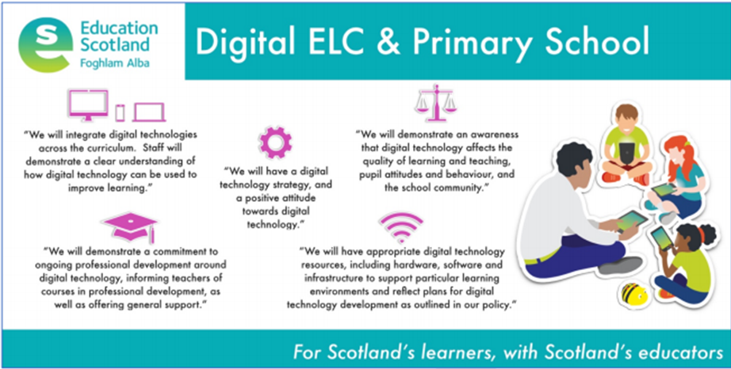

Progression Pathway

Our digital technology progression pathway supports teachers in planning progressive, cohesive and engaging programmes of work. The use of digital technologies enhance learning in other curricular areas. Teachers plan and assess learning and teaching in accordance with experiences and outcomes from the Curriculum for Excellence and with our progression pathways. Digital technologies are used by teachers to present work, support and enhance learning and teaching with appropriate support and differentiation built in.
- Pupils learning will be supported using a range of digital platforms, in three main stages: - Learning how to use specific devices, websites, apps and resources
- Pupils choosing from different digital platforms to, research, create and present work
- Pupils choosing how to develop their learning, knowledge and understand with regards to a particular subject / topic area

See staff dat- “Initiatives”/ “Digital Schools Award”

Additional Support Needs

The following Sway should be used to support staff in using digital tools to improve accessibility for all https://sway.office.com/aZ38VJu35ag79nYS?ref=Link

Some recommended apps and links for ASN children-

- Immersive reader
- Office Lens
- Teach your Monster to read
- Nessy Apps
- Word Hippo
- Book Creator
- Seeing AI – reads environmental text

The iPad accessibility features are also very useful.

https://www.callscotland.org.uk/common-assets/cm-files/posters/ipad-apps-for-learners-with-dyslexia.pdf

https://www.callscotland.org.uk/common-assets/cm-files/posters/ipad-apps-for-learners-with-dyscalculianumeracy-difficulties.pdf

Posters and Leaflets (callscotland.org.uk)

Resources

The following apps and sites should be used along with any additional resources found (where appropriate) to facilitate and enhance learning.

Seesaw
There are many “how to” videos on the Seesaw website which can be used to navigate around this site. Jen Clark and Jen Smith are also Seesaw Ambassadors if you need further support.
- Homework can be submitted on this app weekly
- Portfolios and self/ peer reflections should be submitted on this weekly
- “Family announcements” can be used to communicated reminder to both pupils and parents e.g. a non- uniform day or gym day
- This should be the main site you post on and should be used regularly.

Twitter
- Use this to tag appropriate pages e.g. @hedgehogsociety, @scottishmaths @edscot_maths, @digilearnscot or @pkceducation
- This is to communicate with a wider audience
- Try and post on this site at least once a week
- When posting about digital technology please include out hashtag #digiabernyte

Sumdog
- All pupils and staff should have log ins for this
- This can be used in class or as part of homework

Policy written and reviewed by Digital SIP.

Date: September 2023
To be reviewed: August 2024

