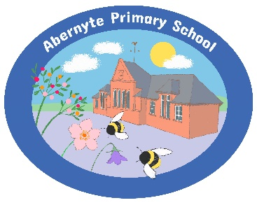
Our Plan to Improve 2023-24

What are we going to do? | How are we going to do it? | How will know? What evidence will we have?
- We will develop our skills, knowledge and confidence in digital technology. | - Weekly digital lessons  - Digital clubs to explore robotics, construction and algorithms  - Improve our skills in touch typing  - Share our learning with parents at PATPAL and through learning journal  - Share our journey with others schools  - Use tools to support our learning such as immersive reader or speech to text. | - Photographs and videos of our skills  - Digital School Award accreditation  - We will get helpful feedback from our peers and adults in school.
- We will all become better writers by increasing our engagement and pace of writing. | - Write with my peers  - Share our writing with others – writing buddies in school, and parents/carers at PATPAL events  - Write more often- 3 times a week  - Invite authors into school  - Themed days to celebrate writing  - Create targets and SC for our levels  - More play and drama experiences to excite writing | - We will see the difference in our cold and hot tasks.  - We will not only receive feedback but also provide it to our peers.  - We will create displays in the school to show our engagement in writing.  - We will have a positive, growth mindset towards writing.

