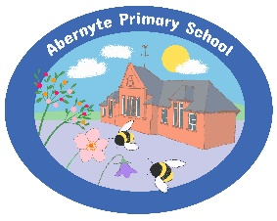
Relationships Policy

Vision:

At Abernyte Primary School, we work as a community to create an ethos where everyone feels they are included, they belong and are cared for. We work in partnership to remove barriers. We want our children to become responsible and successful citizens and we are committed to creating an engaging and empowering climate for learning.

Our “Relationship Policy” has a strong focus on positive behaviours and intrinsic motivation. It focuses on strong and solid relationships and a Restorative Approach. Building strong relationships is at the heart of everything we do at Abernyte Primary. It is something we pride ourselves on and strive to continuously develop.

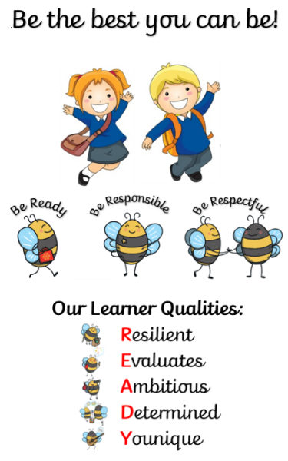
Our core values of Ready, Responsible and Respectful underpin all that we do in the school.

All pupils are involved in decision making in our school. We have pupil focus groups in the school for children from P1-P7: The Eco Committee, Fairtrade Committee, Junior Carsonians, Caring Crew and Party Planners. The children gather to meet regularly enabling them to have their say and to contribute to school improvement.

We encourage all our pupils to respect and care for each other as part of the Abernyte family. P6/7s help the new P1s settle in and act as leaders to take extra responsibility for organising school events.

Abernyte is a school at the heart of the community and we are keen to encourage parents and friends of the school to be actively involved in school life.

Methodology:

How do we promote positive behaviour at Abernyte Primary?

At Abernyte Primary we believe that children learn and develop best when they are part of a culture of mutual respect with clear expectations of how they and others should behave. Through interactions and guidance from trusted and caring adults, who provide a good role model and value their individual personalities, pupils can develop empathy and understanding of how their interactions affect both others and the learning environment.

Our school code of conduct was agreed with pupils and based on the UN Rights of the Child. This session we revisited our school rules, and are happy that they are short and memorable for all pupils:
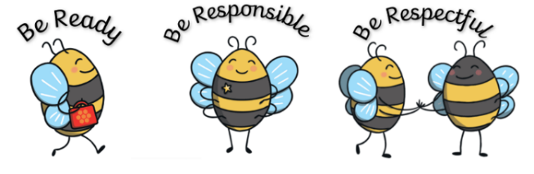

- At Abernyte we are proactive in promoting positive relationships and behaviour in the classroom, playground and the wider school community. We view all behaviour as a communication establishing open, positive, supporting relationships across the community, where children and young people will feel that they're listened to, and where they feel secure in their ability to discuss sensitive aspects of their lives. We use restorative approaches to support communication. When relationships have broken down or incidents have happened that need to be resolved, restorative conversations will take place. These will take place once all parties are calm and have had time to reflect. Sanctions are meaningful, proportionate and immediate. At Abernyte we promote a climate in which children and young people feel safe and secure. Supporting children to develop a growth mindset permeates all aspects of learning and teaching at Abernyte. At Abernyte we ensure that a consistent, high standard of behaviour is expected from all pupils and that a system of positive and fair reinforcement is in place. We ensure that the environment offers a safe base so in developing relationships and wellbeing we ensure an environment that is conducive to learning and takes into account individual needs.

Relationships are central to positive behaviour. Across the school community relationships are positive and supportive and there is a strong sense of community, shared values and high expectations. All staff understand and accept that the responsibility for promoting and developing positive relationships with children lies with them.

All members of staff model high standards of behaviour. Through our 3Rs we demonstrate how we establish and maintain positive relationships and deal with challenging situations when they arise.
We believe that positive behaviour is promoted by the solid relationships we build between; pupils and staff and between staff and parents/carers.

Children are given clear guidelines about appropriate behaviour and expectations based on the 3 Rs which are displayed around the school. These Values are well embedded into the life of the school and are used in the classroom, in and around the school and in the playground.

Each class is also encouraged to consolidate positive behaviour.
Strategies to support positive behaviours and relationships
- Restorative conversations
- Validating feelings
- Discussing whole school behaviour at Pupil focus group time or in class
- Teaching of Zones of Regulation / Emotion works and Growth Mindset
- Well organised school routines with visuals / social stories where appropriate
- High expectations and consistency from all staff
- Specific support for those experiencing barriers to learning
- Communication with parents
- Whole school assemblies and activities on moral and social issues
- Discussion and implementation of aspects of Citizenship within the classes
- Use of ‘buddy’ systems within the school
- Setting of personal targets for improving work and/or behaviour
- Use of taught self-regulation strategies
- Greetings on entering school at the start of the day
- Soft start /play
- Visual timetable for the day
- Safe and nurturing classroom environments with safe-spaces co-constructed with pupil
- A consistency of language is used throughout the school with the use of scripts
- Class / pupil stars linked to school values?

Scripts
- We use scripts to provide predictability and to ensure our language supports de-escalation and regulation. While delivering scripts we are also mindful of our body language, tone of voice and facial expression.

Incident De-escalation Script | Emotional De-escalation Regulation script
I noticed/can see that you are…  I wonder if you are in the... name of zone  Remember we are trying to be  If you continue to be … then you are choosing…  Remember when … (share a positive time when the child was following expectations/doing well  That is what I need to see today.  Thank you for listening | I wonder if you are feeling…  Sometimes when … I feel …  Something that helps me is…

Encouraging and Celebrating Positive Behaviours & Relationships

We believe that children should be encouraged and rewarded for demonstrating our school values of Ready, Responsible and Respectful. We use the following positive rewards, amongst others:

- Non-verbal rewards such as thumbs up or a smile
- Praise
- Showing work to another teacher/staff member or HT
- Stickers (specific of the quality which is being celebrated and valued)
- Certificates (specific of the quality which is being celebrated and valued)
- Letters home / phone calls to parents
- Celebrating achievement on Seesaw, Twitter or the website
- Displaying work
- Awesome Achievement Assemblies
- Prize Giving

In class, at the start of every year, we ask the children to tell us what Ready, Responsible and Respective will look like, feel like and sound like.

Aims
We aim to nurture and develop skills and talents and will encourage pupils to share these with others. We will celebrate success, praise effort and recognise achievements. We will work together to provide interesting learning experiences which support and challenge, inspire and excite and which involve lots of fun, laughter and creativity.
For our families and partners:
- We will work in partnership with our families and other agencies to enable everyone to play an active role making our school the best it can be. We will promote lifelong learning for our children, staff and families. We will provide our staff with meaningful opportunities to develop their skills and abilities to support focus on improvement.

Roles and Responsibilities

Why relationships matter
The research is clear that key protective factors for children are:
- The presence of one positive, consistent, caring relationship in their lives (e.g. this could be with a family member, siblings, neighbours, peers, extended family, staff, youth or community workers) who provides support, encouragement and holds high expectations for the child
- Healthy adult role models (e.g. this could be someone they know or may not know personally but who can positively influence and inspire them)

The Curriculum for Excellence guidelines affirms this research and makes it clear that all members of staff have a responsibility in supporting positive relationships by:
- developing open, positive, supportive relationships where children and young people will feel that they are listened to
- promoting a climate in which children and young people feel safe and secure
- modelling behaviour which promotes effective learning and wellbeing within the school community
- being sensitive and responsive to each child or young person’s wellbeing

Why interactions matter
Human beings are highly social and much of our development and success in life can be dependent on how we interact and relate to other people. Research has found that another key protective factor for children is the extent to which they have received:
- Support to learn and develop key social and emotional skills.

These skills (sometimes referred to as executive functions) include:
- Self awareness
- Ability to regulate emotions and impulses
- Empathy
- Problem solving
- Reasoning and reflective capacity
- Optimistic outlook
- Sense of humour
- Ability to delay gratification
- Perseverance

The Role of the HT
Overall responsibility for maintaining positive discipline throughout the school lies with the Head Teacher. This includes:

- Supporting an ethos where children feel safe, secure and cared for where positive relationships are seen as fundamental.
- Promoting and upholding the Relationships Policy.
- Establishing a culture of positive reward and monitoring the consistent application of this policy.
- Engaging with partners such as Educational Psychologists, Primary Mental Health Workers and Children Service Workers to provide interventions and support when necessary to support the developing and maintenance of positive relationships.
- Offering Nurture sessions to support identified children.
- Ensuring that additional funding streams such as PEF have a HWB element included in order to further support promoting positive relationships.
- Celebrating consistently positive behaviour amongst all children and instilling a sense of pride in those children for demonstrating positive relationships.
- Supporting staff at all levels in managing distressed behaviour through the communication of clear policy and procedures, monitoring incidents and supporting children, staff and families in finding resolutions.
- Facilitating and managing the Staged Intervention approach when required.
- Managing the induction of new staff to ensure they understand this policy and have the support they require to implement it.

The Role of the Class Teacher
Relationships and communication between all adults and children should show respect, cooperation, tolerance, encouragement and praise. They should reflect the underlying principles of nurture and restorative practice. All teachers have responsibility for the maintenance of discipline within their own class.

- Working to promote and uphold the Relationships Policy
- Creating a safe, secure and caring environment
- Establishing and fostering positive relationships
- Have high expectations of all children
- Following restorative approaches to ensure a consistent and fair approach
- Providing a rich, stimulating, varied and challenging curriculum which fosters high levels of pupil engagement
- Ensuring that there is a high level of collaboration and reflection in classroom practice which fosters the development of young people who are mutually supportive, empathetic, encouraging, challenging and tolerant
- Keep a written record of all incidents of a serious nature and ensure that the HT is informed of any such incidents as soon as possible

The Role of Parent/Carer

- Promoting and upholding the Relationships Policy
- Ensuring school staff are aware of any additional needs or personal circumstances which may result in their child displaying behaviours which are not typical of them
- Attending meetings with the Head Teacher or other staff to discuss their child’s behaviour
- Addressing issues to the Class Teacher in the appropriate manner
- Parents/carers are expected to discuss all concerns regarding their child/children with a member of staff and trust that the matter will be investigated, addressed and appropriate action taken. Parents/carers should not approach other children or adults
- Working with the school to support their child’s positive behaviour

Getting It Right For Every Child

While these are standard procedures for supporting children, each child is an individual and so each situation will be dealt with in a manner appropriate to the needs of the child and their family. The diagram below shows the My World Triangle which is central to GIRFEC and the Staged Intervention Process. An interactive version can also be found at -
http://triangle.plexusmedia.co.uk/index.htm
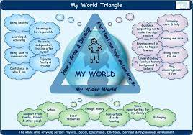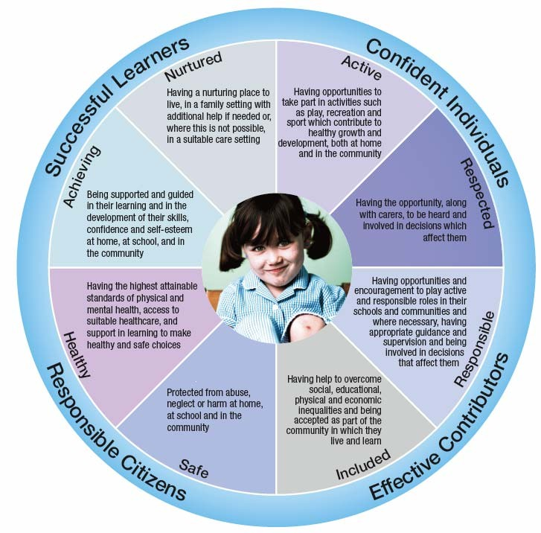

SHANARRI

From the moment a child joins us we are working towards the SHANARRI principles. In order to promote the positive mental health and emotional wellbeing of children the starting point is a positive ethos and climate of respect and trust based upon shared values. Regularly through their education, children will reflect with staff and themselves where they feel they sit within these headings. Above is an example of the SHANARRI wheel with heaadings. Interactive formats and more simplisitc versions can be found at - https://www.gov.scot/publications/shanarri/

Meeting Learning Needs through Staged Intervention

Our school ensures that all children and young people, will become successful learners, confident individuals, responsible citizens and effective contributors. We believe that early intervention and a co-ordinated approach by education, social services and health services are essential in supporting our most vulnerable pupils and ensuring success. We ensure our pupils receive support at levels required to meet their additional support needs by using the Staged Intervention Model.

This may include:
- Solution Focussed Meeting
- Child’s Plan Meeting
- Positive Behaviour Plan
- Individual Education Plan
- Working with partner agencies and other professionals
- Using other, nonspecific, supports, resources, charities and programmes

Health and Wellbeing Curriculum
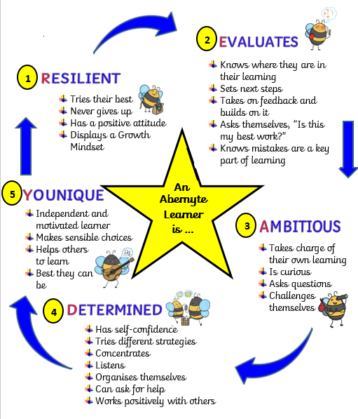
As part of the curriculum, we use various methods to help the children to develop important skills and qualities such as resilience, teamwork, negotiation, risk management and flexibility.

https://education.gov.scot/improvement/scotland-learns/health-and-wellbeing-activities/resilience-alphabet/

https://www.savethechildren.org.uk/what-we-do/coronavirus-information-advice/relaxation-exercises-to-do-at-home-with-your-kids

Consequences

The UNCRC states that “Discipline in schools should respect children’s human dignity” (Article 28).
- In order to protect the rights of our children when relationships have broken down or incidents have happened that need to be resolved, a restorative conversation will take place.
- These will happen once both parties have calmed and are ready to talk it through and will happen away from where the incident took place.
- The conversations will aim to repair relationship and move things forward in a solution focussed way.
- Conversations will be kept simple and will follow emotion talks format.

Restorative Practice Extra Guidance

STEP 1. OPEN THE LINES OF COMMUNICATION.
Let your children know that you will listen to them and their perspectives, then do just that. This is not the time for lectures or judgement. Say:
- How’s it going?
- I wanted to talk with you about ______________ .
STEP 2. ALLOW THEM TO EXPLAIN THE SITUATION FROM THEIR PERSPECTIVE.
Try to see the situation from their point of view. Remember that children, as adults, may often feel very differently about the same event. Say:
- What happened?
- Can you tell me more about __________ .
- What were you thinking at the time?
- What were you feeling?
STEP 3. IDENTIFY WHAT LED UP TO THE INCIDENT AND ANY ROOT CAUSES.
Help your child gain a greater understanding of the situation by asking about what happened before or what else may have affected their behaviour. Remember young children may have a very myopic view of what happened. Say:
- It sounds like you felt __________ . What made you feel that way?
- What happened before it started?
- What else do you think was going on with _________ ?
- Has this happened before?
STEP 4. IDENTIFY THE IMPACT.
Help your child see how their behaviour affected those around them. They may need help understanding consequences they can’t see, such as hurt feelings. Say:
- What happened to you? To your friend? To your family?
- What have you thought about since?
- Who else do you think has been affected/upset/ harmed by your actions? How?
- When I heard/saw __________, I felt __________because I __________.
- What role do you think you played in this situation?
- How do you feel now?

STEP 5. ADDRESS NEEDS AND REPAIR HARM.
Help your child decide how to make things better or solve the problem. Lead them to a resolution they can feel good about, even if it is a consequence. Say:
- What can you do to make things better?
- If you were ______, what do you think you would need?
- What do you need to help you do that?
- What would you like to see happen?
- What could you do to make sure this doesn’t happen again?
- What can you do differently next time?
STEP 6. CREATE AN AGREEMENT.
This may be a verbal agreement, a checklist or even a written letter or contract. Remember to follow through on your own promises. Say:
- Based on our talk, I heard that you will __________. I will also __________.
- Can we agree on this plan?
- I’m going to check on you in a while to see how things are going.
- Thank you for sharing with me! I’m so happy we can work together to make things better!

Sanctions

Serious Breaches of Discipline
Serious breaches of discipline include (but are not limited to):
- Physical violence
- Bullying
- Consistent refusal to comply with requests of staff
- Theft
- Vandalism/destruction of property

In cases where a serious breach of discipline has occurred, the following procedures will be undertaken:
- A full investigation will be carried out
- Parents/carers will be contacted and, where appropriate, a meeting arranged
- Details of the incident will be recorded in the appropriate manner and support/restorative measures put in place where necessary
- Appropriate consequences discussed and carried out

Consequences may include:
- Internal exclusion (child withdrawn from class for a period of time)
- Extended period of exclusion from playground
- External exclusion (temporary exclusion from school)
- Permanent exclusion

Exclusion
If all other interventions are evidenced as having been exhausted, exclusion may be an appropriate
intervention to support learning and wellbeing with the aim of improving outcomes. Under Regulation 4 and 4A of the Schools General (Scotland) Regulations 1975 (as amended)3, it is the education authority which has the power to exclude children from school. The Education (Scotland) Act 1980 places a duty on education authorities to make appropriate education provision when a child or young person is excluded. These powers (to exclude and make appropriate provision during exclusion) can be devolved by education authorities to senior management within a school. Regulation 4 and 4A provides that an education authority shall not exclude a child or young person from school unless the authority: “…is of the opinion that the parent/carer of the pupil refuses or fails to comply, or to allow the pupil to comply, with the rules, regulations, or disciplinary requirements of the school”; or “…considers that in all the circumstances to allow the pupil to continue his attendance at the school would be likely to be seriously detrimental to order and discipline in the school or the educational well-being of the pupils there”. Excluding a child or young person for any other reason/purpose has no legal basis. (Revised Management Circular No. 8, August 2018)

Resources:

- https://www.highland.gov.uk/downloads/file/166/positive_behaviour_guidelines
- https://www.perlego.com/book/568229/when-the-adults-change-everything-changes-seismic-shifts-in-school-behaviour-pdf
- https://www.nhshighland.scot.nhs.uk/Services/Pages/CAMHS.aspx
- https://highlandcouncilpsychologicalservice.wordpress.com/core-training-2019-2020/promoting-positive-relationships-developing-emotional-literacy-and-resilience/

